Project Requirements

# Expectations:

INX Future Inc, with best HR practices, has seen few escalations and downfall in Employee Performances in recent past. So, the company expects to gain insights into various factors that are impacting service delivery and client satisfaction. CEO, Mr. Brain, being a Data Scientist himself, wants to initiate a project, which analyses the current employee data and find the core underlying causes of this performance issues.

The Company specifically wants to gain more insights about the following points.

* How Performance is distributed across different Departments.
* Which are the top 3 factors causing the downfall of Employee Performances.
* A trained Machine Learning model, which can predict the employee performance based on factors as inputs. Which, in turn can be used to hire future employees.
* Recommendations to improve the employee performance based on insights from analysis.

# Department wise Performance

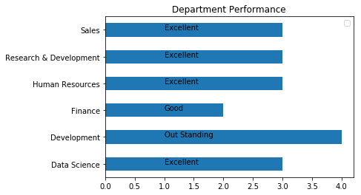

The above Bar graph, indicates how the Employee performance is spread across the Departments. Development department Out performs all other departments, whereas Finance lacks improvement. Other departments show same kind of performance throughout.

# Top 3 Important Factors effecting employee performance

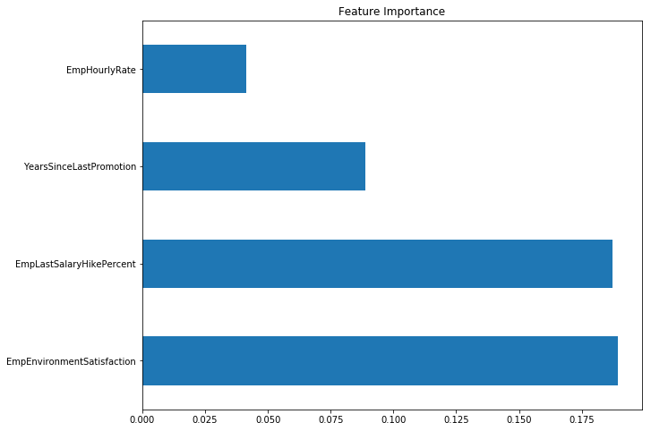

The figure shown above, clearly indicates that the ‘Employee Environment Satisfaction and Employee Last Salary Hike Percentage’ features have a huge impact on Employee Performance. So, by providing better work environment and increasing the perks and hikes could resolve the issue and improve the performances of existing employees.

# Trained Model

A trained Machine Learning model, using the Random Forest algorithm, (Employee Rating.ml) has been placed in the Model folder. Based on the inputs provided this ML model is capable of predicting the performances of future employees as well.

# Recommendations

The figure given below, Feature Importance, shows that ‘Employee Environment Satisfaction and Employee Last Salary Hike Percent’ are the major factors impacting the overall Employee Performance. Based on the analysis and Insights gained about the data, improving the work environment and providing regular hike and Bonuses to employees could increase the overall productivity.

Submitted By: Kiran B Kulkarni.